Selenium WebDriver
Session: 6
Topics:
# | Subject name
1 | Introduction to POM class  @FindBy annotation
2 | Introduction TestNG  Test class and Test methods  TestNG Suite file [TestNG.xml]
3 | Test Annotations  Parameters
4 | Introduction to Automation Framework  Assertions

- Introduction to POM Class
In the previous session we had discussed about the Declaration, Initialization and utilization of elements stored in a web page using the concept of Encapsulation
Let’s see another example for the below scenario
Scenario: Click on “Login” button without entering any value in “username” and “Password” text box and print the error message displayed
public class loginPage {

WebElement errorMsg;
WebElement loginBtn;
WebDriver driver = new FirefoxDriver();

public loginPage()
{
errorMsg=driver.findElement(By.xpath("//span[contains(text(), 'invalid')] "));
loginBtn= driver.findElement(By.id("loginButton"));
}

public void clickLogin()
{
loginBtn.click();
}

public void printError()
{
String errMsg=errorMsg.getText();
System.out.println(errMsg);
}

public static void main(String[] args) {

loginPage login= new loginPage();
login.clickLogin();
login.printError();
}

On running the above code, we will get the below exception saying
“Exception in thread "main" org.openqa.selenium.NoSuchElementException: Unable to locate element: {"method":"xpath","selector":"//span[contains(text(), 'Username')]"}”
The above exception is thrown by compiler because,
When we want to click on login button without entering the user name and password to verify the presence of error message, we need to do the following steps:
- Use “clickLogin” method present in “loginPage”- to click on Login button
- To use “clickLogin” method create the object of “loginPage” class
- When the object of class “loginPage” is created, it will call the constructor of “loginPage” class
- In “loginPage” class constructor, initialization of “loginBtn” and “errorMsg” is done. loginBtn is already present in the Web page but “errorMsg” is not present
- In order to have “errorMsg” in the web page, we need follow all above 4 steps.
This will lead to a “Dead lock”.
<Diagram explaining the Dead Lock>
Hence the concept of POM class is introduced.
POM:
- Page Object Model is a Java design pattern used by developers to develop the web pages. The same concept is used test the web pages here
- In POM, we will declare the elements using “FindBy annotation” [@FindBy] as shown below
- POM Class is basically used to store all the elements present in a Webpage and methods specific to that page.
@FindBy(id="username")
private WebElement unTB;

@FindBy(name="pwd")
private WebElement pwdTB;

@FindBy(xpath="//span[contains(text(), 'invalid')]")
private WebElement errorMsg;

@FindBy(id="loginButton")
private WebElement loginBtn;

public loginPage(WebDriver driver)
{
PageFactory.initElements(driver, this);
}

public void clickLogin()
{
loginBtn.click();
}

public void printError()
{
String errMsg=errorMsg.getText();
System.out.println(errMsg);
}
public static void main(String[] args){

WebDriver driver = new FirefoxDriver();;
driver.get("http://localhost/login.do");
loginPage login= new loginPage(driver);
login.clickLogin();
login.printError();

}

On executing the above code, the error message is printed without any error
Explanation:
On declaring the web elements using @FindBy and initializing the elements in the constructor using “PageFactory.initElements (driver, this)” in POM Class, the web elements will NOT be initialized soon after the creation of the object. I.e., during compilation the objects will not be initialized
Instead the elements will be initialized during the run time. This is called as Lazy initialization.
During the run time, PageFactory.initElements () method will convert the elements stored under @FindBy like:
Private WebElement loginBtn= driver.findElement(By.id("loginButton"));
- As discussed earlier, POM class is used to store all the web elements and corresponding methods
- For every web page in an application there should corresponding POM class
- Similarly for every test case, we should develop test class using the concept of TestNG framework.

- Introduction to TestNG:
[TestNG – Test Next Generation] is a testing framework basically used by developers to perform the following steps
- Run multiple test cases
- Generate the result
- Re-run the failed cases

In selenium also we will use the same framework to test the web pages.

TestNG is a plug-in available in Eclipse and in order to install it follow the below steps:
- Open Eclipse, Go to Help-> Eclipse Marketplace
- Search TestNG
- Click “Install” button of TestNG
- Follow the default instructions to complete the installation

If the Eclipse Marketplace option is not available then follow the below steps
- Select “Install New Software” option from “Help” menu
- Click ‘Add’- Specify the URL: http://beust.com/eclipse
- Click ‘OK’
- Select “TestNG” check box and follow the default instructions to complete the installation

Restart Eclipse after the installation is complete.
Now, Right click on Project folder-> Properties-> “Java Buildpath” tab-> “Libraries”-> Click “Add Library” button-> Select “TestNG” and click “Finish”

TestNG class:
- It is a java class which contains “test methods” written using @Test [Test Annotation] instead of main method
- On running any TestNG class, a test execution report will be generated automatically in HTML format inside “test-Output” folder with the name “emailable- report.html”
- In order to print any statements in the report use Reporter.log(<statement>);
- If the same statement should be printed in console then use ‘true’ in “reporter.log” as shown below
Reporter.log (<statement>, true);
Ex: Reporter.log (“Execution of test class begins”, true);
- It is a good practice to create the test class and POM class by creating a new package with some name instead of creating inside a default package.

POM Class:
package POM;
import org.openqa.selenium.By;
import org.openqa.selenium.WebDriver;
import org.openqa.selenium.WebElement;
import org.openqa.selenium.firefox.FirefoxDriver;
import org.openqa.selenium.support.FindBy;
import org.openqa.selenium.support.PageFactory;

public class loginPage {
@FindBy(id="username")
private WebElement unTB;

@FindBy(name="pwd")
private WebElement pwdTB;

@FindBy(xpath="//span[contains(text(), 'invalid')]")
private WebElement errorMsg;

@FindBy(id="loginButton")
private WebElement loginBtn;

public loginPage(WebDriver driver)
{
PageFactory.initElements(driver, this);
}

public void login(String userName, String Password)
{
Reporter.log ("Inside the login method of 'Login' class");
unTB.sendKeys(userName);
pwdTB.sendKeys(Password);
loginBtn.click();
}
}

Test NG class:
package TestScript;

import org.openqa.selenium.WebDriver;
import org.openqa.selenium.firefox.FirefoxDriver;
import org.testng.annotations.Test;

import POM.loginPage;
public class Login2Application {

@Test
public void VerifyLogin()
{
WebDriver driver = new FirefoxDriver();
loginPage l = new loginPage(driver);
l.login("admin", "Manager");
}
}
We can have any number of TestNG classes. In order to run the multiple TestNG classes, we use TestNG suite file.

TestNG suite:
- It is an XML file having all TestNG classes which are to be executed.
- In order to create TestNG suite file, Right click on the Java Project file -> Go to TestNG-> select “convert to TestNG” option. This will create a TestNG.xml file inside the project folder
- To run “TestNG.xml” file, Right click on TestNG.xml file-> Select Run as-> TestNG suite

Typical TestNG suite file [TestNG.xml]:

<?xml version="1.0" encoding="UTF-8"?>
<!DOCTYPE suite SYSTEM "http://testng.org/testng-1.0.dtd">
<suite name="Suite">
<test name="Test">
<classes>
<class name="TestScript.Login2Application"/> //Login2Application TC is executed
</classes>
</test> <!-- Test -->
</suite> <!-- Suite -->

After the execution of “testNG.xml” file, the result file “emailable-report.html” will be stored inside “test output” folder which has the test class “Pass/ Fail” information along with the statements included in “Reporter.log” method and statements included in assertions if used.

Typical TestNG report looks like:
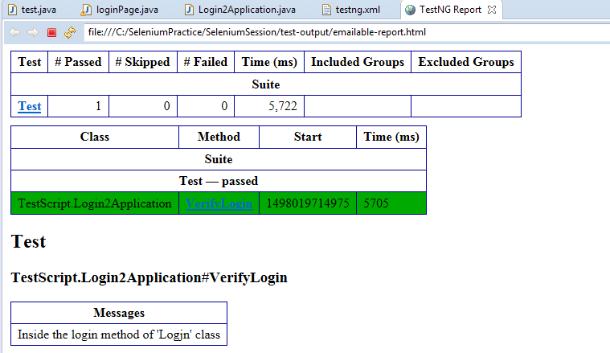
Below diagram shows the “test-Output” folder and opening the “emailable-report.html” file using “Web Browser”
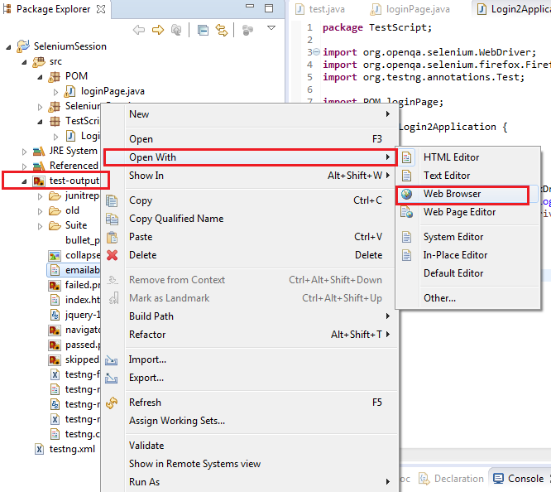

- Test Annotations:
Here are some of the important annotations which are commonly used in TestNG

- @BeforeSuite
- @AfterSuite
- @BeforeClass
- @AfterClass
- @BeforeMethod
- @AfterMethod
- @BeforeTest
- @AfterTest
- @Test
- @dataProvider [for data driving the test cases]

All the above mentioned annotations are present in “org.testng.annotations” and should be imported from the same package.
Annotation | Description
@BeforeSuite | The annotated method will be run only once before all tests in this suite have run.
@AfterSuite | The annotated method will be run only once after all tests in this suite have run.
@BeforeClass | The annotated method will be run only once before the first test method in the current class is invoked.
@AfterClass | The annotated method will be run only once after all the test methods in the current class have run.
@BeforeTest | The annotated method will be run before any test method belonging to the classes inside the <test> tag is run.
@AfterTest | The annotated method will be run after all the test methods belonging to the classes inside the <test> tag have run.
@BeforeMethod | The annotated method will be run before each test method.
@AfterMethod | The annotated method will be run after each test method.
@DataProvider | Marks a method as supplying data for a test method. The annotated method must return an Object[ ][ ], where each Object[ ] can be assigned the parameter list of the test method. The @Test method that wants to receive data from this DataProvider needs to use a dataProvider name equals to the name of this annotation.
@Test | Marks a class or a method as a part of the test.

PreSetup.java:
package testSuite;
import org.testng.Reporter;
import org.testng.annotations.AfterMethod;
import org.testng.annotations.AfterSuite;
import org.testng.annotations.AfterTest;
import org.testng.annotations.BeforeMethod;
import org.testng.annotations.BeforeSuite;
import org.testng.annotations.BeforeTest;

public class PreSetup {
@BeforeSuite
public void beforeSuite()
{
Reporter.log("Before Suite- Clear all Logs, History", true);
}

@AfterSuite
public void afterSuite()
{
Reporter.log("After Suite- Close all activities", true);
}

@BeforeTest
public void browserSpecificBefore()
{
Reporter.log("Before Test:Do the Browser Specific Settings", true);
}

@AfterTest
public void browserSpecificAfter()
{
Reporter.log("After Test: Do the Browser Specific Settings ", true);
}

@BeforeMethod
public void loginTest()
{
Reporter.log("Before Method: loginTest", true);
}

@AfterMethod
public void logOut()
{
Reporter.log("After Method: logOut", true);
}
}

testCase1.java
package testSuite;
import org.testng.Reporter;
import org.testng.annotations.Test;

public class testCase1 extends PreSetup{

@Test
public void test1()
{
Reporter.log("test case 1", true);
}
}

testCase2.java:
package testSuite;

import org.testng.Reporter;
import org.testng.annotations.Test;

public class testCase2 extends PreSetup{

@Test
public void test2()
{
Reporter.log("test case 2", true);
}
}

Output:
Before Suite- Clear all Logs, History
Before Test: Do the Browser Specific Settings
Before Method: loginTest
test case 2
After Method: logOut
Before Method: loginTest
test case 1
After Method: logOut
After Test: Do the Browser Specific Settings
After Suite- Close all activities

We can use the below parameters along with @Test [Test annotation] for different purpose as mentioned below

Parameter Name | Default value | Description
Priority | 0 | Used to set the priority of test method execution.  By default: Test methods are executed based on Alphabetical order
invocationCount | 1 | Used to run the test method specified number of times
Enabled | True | Used to enable/ disable the test method from being executed
dependsOnMethods | {“<Method Name>”} | If there is a dependency between 2 methods.  Ex: if a particular test method say: “DeleteUser” needs to be executed only after the execution of test method “createUser” then we can use it.

Note:
- Priority can have both –ve number, +ve number and zero but cannot be decimal value
- InvocationCount can only be a +ve number but not –ve number and decimal value
- enabled can have only Boolean value. i.e., true or false
- dependsOnMethods can have single method or multiple methods separate by comma.
Ex:
@Test (dependsOnMethods= {“createUser”, “editUser”})
Public void deleteUser ()
{
Reporter.log (“Delete User method”);
}

Now, deleteUser method is executed only after “createUser” and “editUser” methods are executed.

Example:

package SeleniumPractice;

import org.testng.Reporter;
import org.testng.annotations.*;

public class Sample {
@Test(dependsOnMethods={"createUser"})
public void deleteUser()
{
Reporter.log("Delete User Method", true);
}

@Test(priority=1)
public void createUser()
{
Reporter.log("Create User Method", true);
}

@Test(invocationCount=2)
public void EditeUser()
{
Reporter.log("Edit User Method", true);
}}

Output:

Create User Method
Edit User Method
Edit User Method
Delete User Method

@DataProvider
- DataProvider annotation is basically used to store the values in 2-D Object array
- It can be used to data drive a test method by using “dataProvider” parameter

Example:

package SeleniumPractice;
import org.testng.Reporter;
import org.testng.annotations.DataProvider;
import org.testng.annotations.Test;

public class dataProviderExample {
@Test(dataProvider="ProductDetail")
public void productInfo(String name, int cost)
{
Reporter.log("Name of the Product is: "+name+" cost is: "+cost, true);
}

@DataProvider(name="ProductDetail")
public Object[][] getData()
{
Object[][] data= new Object [3][2];
data[0][0]="Plates";
data[0][1]=100;
data[1][0]="Books";
data[1][1]=200;
data[2][0]="Furnitures";
data[2][1]=500;

return data;
}
}
Note:
- Number of times the test method is executed is based on the number of rows present in the array
- DataProvider has 2 types of return types. They are: object [][], String[][]

4. Introduction to Automation Framework:

- Main intention to move to automation testing is to reduce the time and effort involved in manual testing
- Most repetitive tasks/test cases which are executed manually needs to be automated such as Regression test suite
- Generally the automation test engineers develop the automation test cases in their local machines by following some standards set by the lead or architect
- In order to have a consistency is automation test case development and framework development. There are 3 stages in automation. They are:
  - Design
  - Implementation
  - Execution

Design:
- In this stage, Lead/ Manager will specify the naming convention to be followed for creation of class [Camel Convention], method[Pascal Convention] and variables [Hungarian Notation]
- Other things such as Indentation, Inline comments etc
- Number of POM classes= Number of Web pages
  - Name of POM Class should always end with the suffix page
Ex: loginPage, userCreationPage, JDEHomePage (Specific Oracle JDE application)
  - POM class is an Element repository having the locator information of all the web elements and the required methods
- Number of Test classes= Number of test cases
  - Name of the testClass should be same as Manual Test case name
  - Test class is a collection of test methods
  - Test class will create the object of the required page and call the required method
- Software requirements
  - Jdk
  - Eclipse IDE
  - Selenium Standalone Jars
  - Firefox browser, FireBug and Firepath
  - Internet Explorer browser and driver file
  - Chrome browser and driver file
  - TestNG plug-in
  - MS Office
  - POI jars
  - Jenkins
  - SVN
  - Maven

- Important file types and locators
  - .java → <JavaProject>/src
  - .class → <JavaProject>/bin
  - .xml → <JavaProject>
  - .html → <JavaProject>/test-output

Create the folders named “exeFiles”, “excelFiles”, “JarFiles” inside the project folder and stored the corresponding files
  - .exe → <JavaProject>/exeFiles
  - .xlsx → <JavaProject>/excelFiles
  - .bat→ <JavaProject>
  - .jar→ <JavaProject>/jarFiles

Implementation:
- Create a folder in the required location. Say C:\AutoFramework
- Open Eclipse
- Navigate to File-> Switch to Workspace-> Others
- Browse and select the above created folder and click “OK”; Eclipse restarts
- Go to File-> New -> Java Project
- Specify the name and click “Finish”; ensure that “bin” and “src” folders are created under C:\AutoFramework folder
- Create 3 new folders: “exeFiles”, “excelFiles” and “JarFiles” inside the folder “C:\AutoFramework folder”
- Copy and paste “Selenium Standalone jars” in “JarFiles” folder
- Copy and paste “ChromeDriver.exe”, “IEdriverserver.exe” files in “exeFiles” folder
- Go to Eclipse and refresh the project folder “AutoFramework” to view the above created folders and the files under respective folders
- Go to “JarFiles” folder and right click on “Selenium Stand alone jars” and select Build Path-> Add to Build path; all the Jar files will be added and displayed under “Referenced Libraries” folder
- Right click on any of the jar files under “JarFiles” folder, select “Properties” option and observe that “Path” is displayed as “/AutoFramework/JarFiles/” [This is the ideal way to associate the jar files instead of adding the jars using the option: ”Add External Jars” in “Java Build path”]
- Associate TestNG library: Java BuildPath-> Add Library-> Select TestNG
- Create 2 new packages named : POM and Scripts

Test cases to automate:
Demo application name: actiTime
URL: http://localhost/login.do
Username/ Password: admin/ manager

<Demo>

Assertions:
- Assert statements are basically used to validate the actual against the expected value and make decision based on the outcome.

Here are the list of static methods present in assert class hence we can access these methods directly using class name.
Method name | Description
assertEquals(<actual>, <expected>, <message>) | Used to compare 2 values for equality. If not equal then prints the message in <Message> section
assertNotEquals(<actual>, <expected>, <Message>) | Used to compare 2 values for not equal. If equal then prints the message in <Message> section
assertTrue(<value>, <Message>) | Checks whether the <value> is True, and prints the message if NOT true
assertFalse(<actual>, <expected>, <Message>) | Checks whether the <value> is False, and prints the message if NOT False
assertNull(<value>, <Message>) | Checks whether the <value> is null and prints the message if NOT null
assertNotNull(<value>, <Message>) | Checks whether the <value> is NOT null and prints the message if null
assertSame(<object1>, <object2>, <Message>) | Checks whether both objects are same. If not same then prints the message
assertNotSame(<object1>, <object2>, <Message>) | Checks whether both objects are NOT same. If same then prints the message
assertFail()

Assert and SoftAssert statement

